

DVTK Design Specification
IHE Actors Assembly
(and associated assemblies)

Version 0.2
2006-03-07
Table of Contents
1 Introduction 4
1.1 Purpose 4
1.2 Scope 4
1.3 Audience 4
1.4 Abbreviations and acronyms 4
1.5 References 4
1.6 History 4
2 DVTK IHE Actor Concepts 5
2.1 Introduction 5
2.2 IHE Actors / DVTK IHE Actors 5
2.3 Example – Acquisition Modality SUT 6
2.4 Example – DSS/Order Filler SUT 7
2.5 Test Actors 7
2.6 Test Data 8
2.6.1 DCM Files 8
2.6.2 Loadable Templates 8
3 Detail Design of Integration Profile Classes 9
3.1 Introduction 9
3.2 Overview of Major Participating Classes 9
3.2.1 IntegrationProfile Class 9
3.3 Sequence Diagrams 10
3.3.1 Test Execution 10
4 Detailed Design of the IHE Actor Classes 11
4.1 Introduction 11
4.2 Overview of Major Participating Classes 11
4.2.1 Configuration Classes 11
4.2.1.1 ActorConfigCollection Class 11
4.2.1.2 DicomConfig Class 12
4.2.1.3 Hl7Config Class 13
4.2.2 Example XML Configuration of the DVTK IHE DssOrderFiller Actor 13
4.2.3 Actor Classes 15
4.2.3.1 ActorCollection Class 15
4.2.3.2 Actor Class 16
4.2.3.3 DicomServer Class 18
4.2.3.4 DicomClient Class 19
4.2.3.5 Hl7Server Class 21
4.2.3.6 Hl7Client Class 21
4.2.4 Transaction Classes 22
4.2.4.1 ActorsTransactionLog Class 22
4.2.4.2 DicomTransaction Class 23
4.2.4.3 Hl7Transaction Class 23
4.2.5 Trigger Classes 24
4.2.5.1 DicomTrigger Class 24
4.2.5.2 Hl7Trigger Class 24
4.3 Sequence Diagrams 25
4.3.1 DICOM Server Lifecycle 25
4.3.2 DICOM Client Lifecycle 25
4.3.3 HL7 Server Lifecycle 26
4.3.4 HL7Client Lifecycle 26
5 Detailed Design of the Specialized DICOM Server Classes 27
5.1 Introduction 27
5.2 Overview of Major Participating Classes 27
5.2.1 DICOM Server Classes 27
5.2.1.1 DicomMppsServer Class 27
5.2.1.2 DicomPrintServer Class 28
5.2.1.3 DicomQueryRetrieveServer Class 29
5.2.1.4 DicomStorageServer Class 30
5.2.1.5 DicomStorageCommitServer Class 31
5.2.1.6 DicomWorklistServer Class 32
6 Detailed Design of the Information Entity Classes 33
6.1 Introduction 33
6.2 Overview of Major Participating Classes 33
6.2.1 Query/Retrieve Classes 33
6.2.1.1 Query/Retrieve Information Entity Classes 33
6.2.1.2 Patient Root Query/Retrieve Information Model Classes 34
6.2.1.3 Study Root Query/Retrieve Information Model Classes 35
6.2.1.4 Patient/Study Only Information Model Classes 36
6.2.2 Modality Worklist Classes 36
6.2.2.1 Modality Worklist Information Entity Classes 36
6.2.2.2 Modality Worklist Information Model Classes 38
7 Detailed Design of the Comparator Classes 39
7.1 Introduction 39
7.2 Overview of Major Participating Classes 40
7.2.1 BaseComparatorCollection Class 40
7.2.2 DicomComparator Class 41
8 Detailed Design of the Common Data Format Classes 43
8.1 Introduction 43
8.2 Overview of Major Participating Classes 43
8.2.1 Common Data Format Classes 43
9 DVTK Assembly Dependencies 44

Introduction

Purpose
This document describes the DVTK IHE Actors concepts and global and detail design. This is a living document and changes in the design should be laid down in this document.

Scope
The DVTK IHE Actors assembly implements a set of IHE Actors which can be used together with a SUT to complete the Actor requirements for a given IHE Integration Profile. The DVTK IHE Actors are simulations of real-world devices allowing the SUT to be tested in a “System-Wide” environment.

The initial DVTK IHE Actors assembly will support Actors using the DICOM and HL7 message protocols only. Future versions may support other message protocols as needed by the Integration Profile being tested.

This initial design is limited to the IHE Actors needed to support the Scheduled Workflow Integration Profile. It is seen as a proof-of-concept before implementing other IHE Actors used in other Integration Profiles.

The implementation lacks an HL7 library at the moment so only the DICOM aspects are fully available.

Audience
This document is intended for all the implementers in the DVT project. The reader is assumed to have basic IHE, DICOM and HL7 knowledge.

Abbreviations and acronyms
Abbreviation / acronym | Description
SUT | System Under Test

References
Reference | Title | Author/Publisher | Document number
DICOM | DICOM standard 2004 | NEMA | PS 3.0-2004
IHE | IHE Technical Framework | IHE
HL7 | HL7 standard V2.x | HL7

History
Version | Date | Author | Description
0.1 | 03 February 2006 | Rick Busbridge | Initial version
0.2 | 07 March 2006 | Rick Busbridge | Update after review by Agfa and Philips Interoperability Engineers.

DVTK IHE Actor Concepts

Introduction
The DVTK IHE Actors assembly provides the means to test devices taking part in an IHE Integration Profile. The intention is that the DVTK IHE Actors take the place of any missing real-world actors in a test scenario.

The DVTK IHE Actors assembly should be seen as an IHE Test Tool Box. The tool box contains actor simulations so that a SUT (System Under Test) can be fully tested in a given integration profile.

The validation of all DICOM communication is done using the DVTK Validation Engine which provides very clear validation results of the DICOM message exchange.

It includes the ability to check the values of the same attributes between any kind of messages – example: comparing the Patient Id between a DICOM Modality Worklist query and a DICOM Storage operation and an HL7 Patient Registration.

In addition, the DVTK IHE Actors assembly can be loaded with test data that makes regression testing very easy.

The DVTK IHE Actors assembly can be used by any kind of GUI/Command Line application, driven by VBScripts or Automated Test Tools like NUnit.

IHE Actors / DVTK IHE Actors

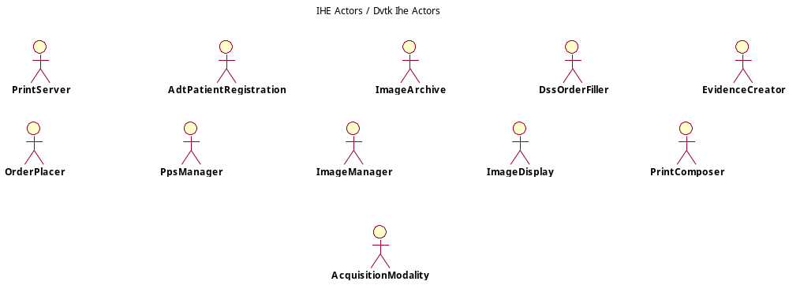

These are the IHE Actors supported in the first version of the Assembly – see the IHE Technical Framework for a definition of each actor.

Example – Acquisition Modality SUT
The following diagram shows the use the DVTK IHE Actors assembly when testing an Acquisition Modality in the Scheduled Workflow Integration Profile. 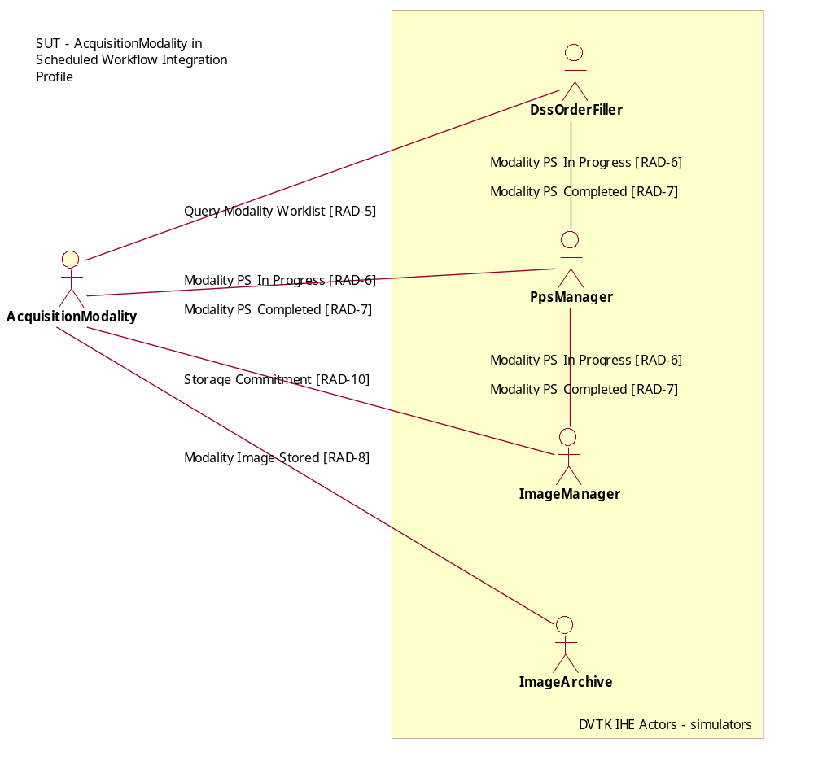

It can be seen that DVTK takes on the roles of the DssOrderFiller, PpsManager, ImageManager and ImageAcrhive actors. All transactions passed between the actors during the execution of the scheduled workflow test scenarios will be validated and where appropriate attribute values compared with each other. The results are produced in XML/HTML format.

Example – DSS/Order Filler SUT
The following diagram shows the use the DVTK IHE Actors assembly when testing a DSS/Order Filler in the Scheduled Workflow Integration Profile. 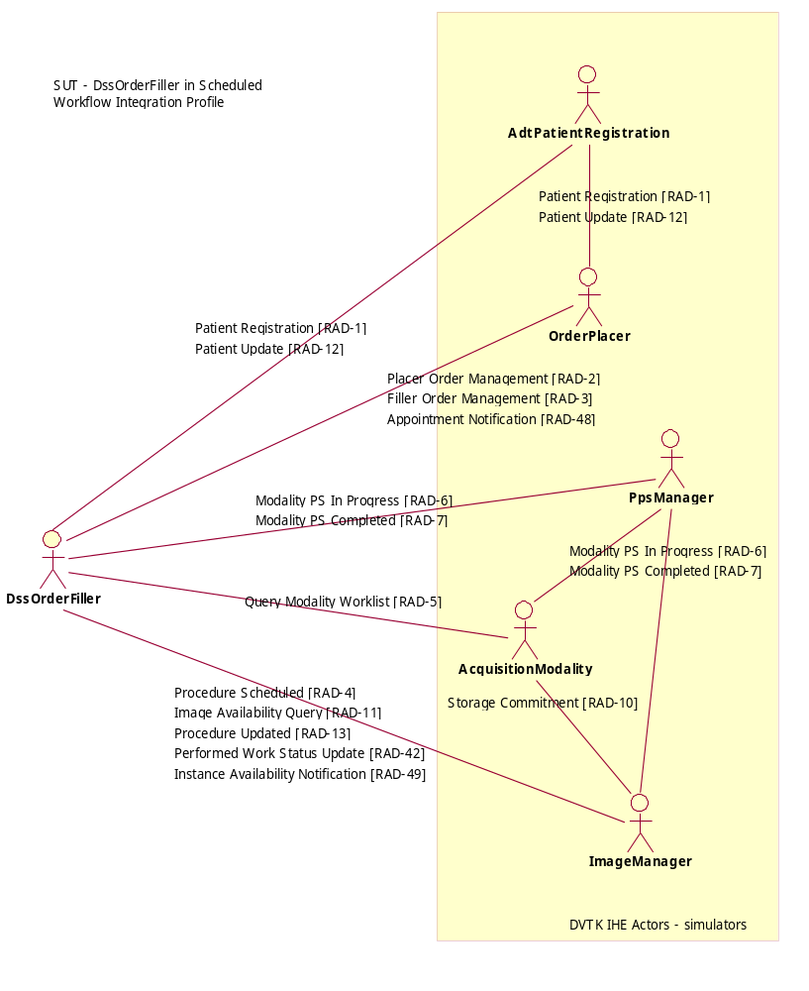
It can be seen that DVTK takes on the roles of the AdtPatientRegistration, OrderPlacer, PpsManager, AcquisitionModality and ImageManager actors.

Note: The transactions are also sent between DVTK actors (internally). These transactions will also form part of the validated results.

Test Actors
A number of test actors are defined which take on roles with the DVTK IHE Actor assembly use.
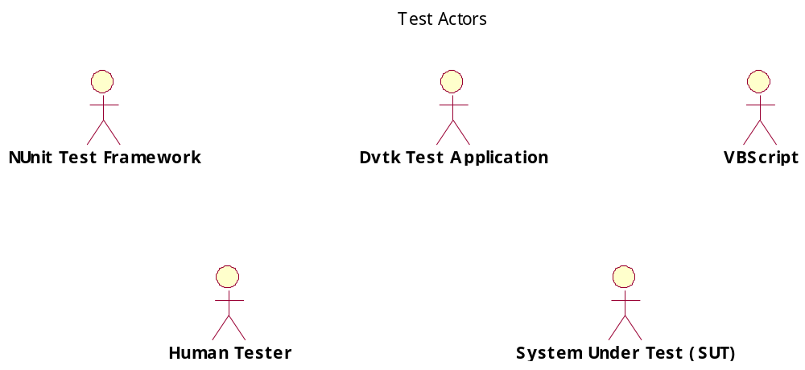

- NUnit Test Framework – this is the NUnit actor making use of the DVTK IHE Actors assembly from within the NUnit automated test framework.
- DvtkTestApplication – this can be either a GUI or command line application which make use of the DVTK IHE Actors assembly to provide the required application functionality.
- VBScript – test scenarios can be written in VBScript. The VBScript can make use of the DVTK IHE Actors assembly to provide the required scenario functionality.
- Human Tester – actor making use of the NUnit Test Framework, Dvtk Test Application or VBScripts.
- System Under Test (SUT) – this is the real-world actor (or device) which is being tested using the DVTK IHE Actors assembly.

Test Data
The DVTK IHE Actors assembly requires test data to be available to provide, for example, Modality Worklist Items, Query/Retrieve capabilities and Storage object contents.

DCM Files
Test data can be read from DCM files into the DVTK Information Models (see section - Detailed Design of the Information Entity Classes). These DCM files are normalized into the required Information Model. Data stored in DCM files during DICOM store operations is also available in the Information Models.

Loadable Templates
Test functionality can also be modified by loading various data templates. These templates are used in the DvtkComparator assembly and DvtkInformationEntity assembly – see sections Detailed Design of the Information Entity Classes and Detailed Design of the Comparator Classes.

Detail Design of Integration Profile Classes

Introduction
The Integration Profile is the main test container class. It is the integration profile that is being tested. The integration profile contains all the actors needed to simulate the test together with the SUT.

The integration profile class can be used from a GUI or command line application, from a scripting language like VBScript or within a test framework like NUnit.

Overview of Major Participating Classes

IntegrationProfile Class
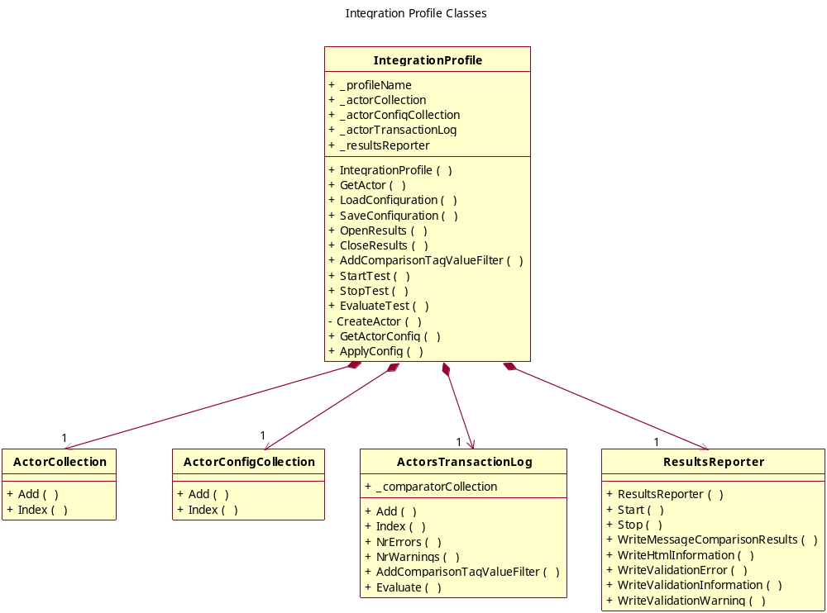

The DVTK actor configuration is read from an XML configuration file. The actors started within the integration profile depend on the configuration content. If an actor is not defined then it will not be instantiated during the test.

The configuration file is read into the ActorConfigCollection class using the IntegrationProfile.LoadConfiguration() method.

Once done the IntegrationProfile.ApplyConfig() method can be called on this class and the configuration used to build up the ActorCollection class content. This ActorCollection class contains all the actors defined in the integration profile.

The ActorsTransactionLog is passed to each of the Actors so that all transactions handled by the Actors can be stored in the ActorsTransactionLog.

The test is started using the IntegrationProfile.StartTest() method. All defined actors will be started.

The test scenario is then executed and the IntegrationProfile.StopTest() method called once the test is complete.

The IntegrationProfile.EvaluateTest() method will evaluate the transactions handled during the test by comparing appropriate attribute values with each other .

The ResultsReporter class is used to write the test results out to the results file.

Sequence Diagrams

Test Execution
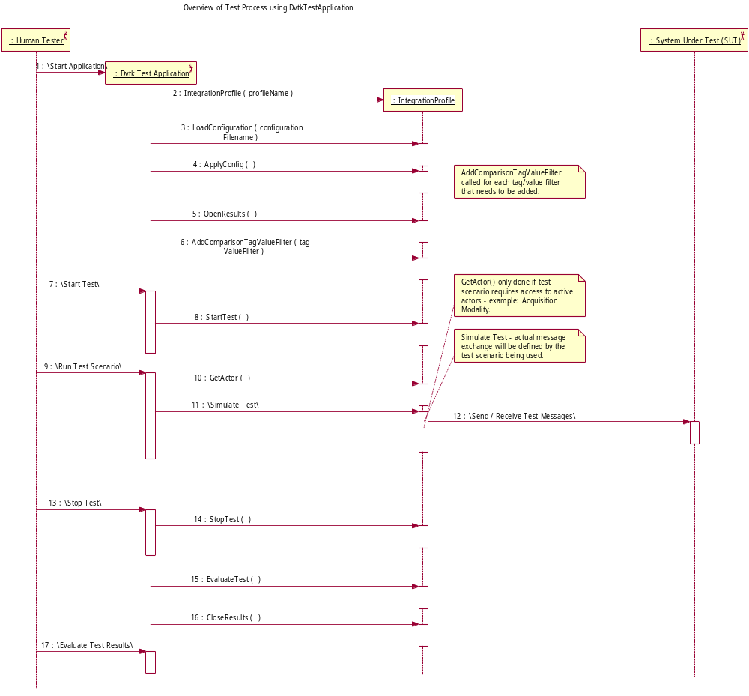

The sequence diagram above shows the normal test execution workflow. The start/stop/evaluate cycle is needed so that once a test scenario has been executed the test tooling can be stopped and the results evaluated.

Detailed Design of the IHE Actor Classes

Introduction
The IHE Actor classes are a realization of the Actors defined in the IHE Technical Framework.
In the current version of DVTK these actors will support both the DICOM and HL7 protocols.

A DVTK IHE Actor is composed of a number of HL7 Clients, HL7 Servers, DICOM Clients and DICOM Servers. The exact combination depends on the Actor description.

The DVTK IHE Actor is instantiated from the ActorConfig class for the given actor.

Overview of Major Participating Classes

Configuration Classes

ActorConfigCollection Class
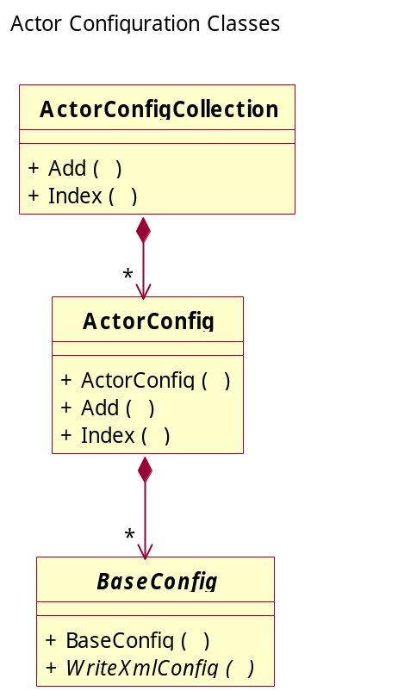

The ActorConfigCollection class contains the configuration details of all actors that are to take part in the integration profile test alongside the SUT. This collection should define all the actors that the SUT requires in order to be tested.

The ActorConfig class contains a number of DicomConfig and Hl7Config classes – again based on the definition of the actor.

DicomConfig Class
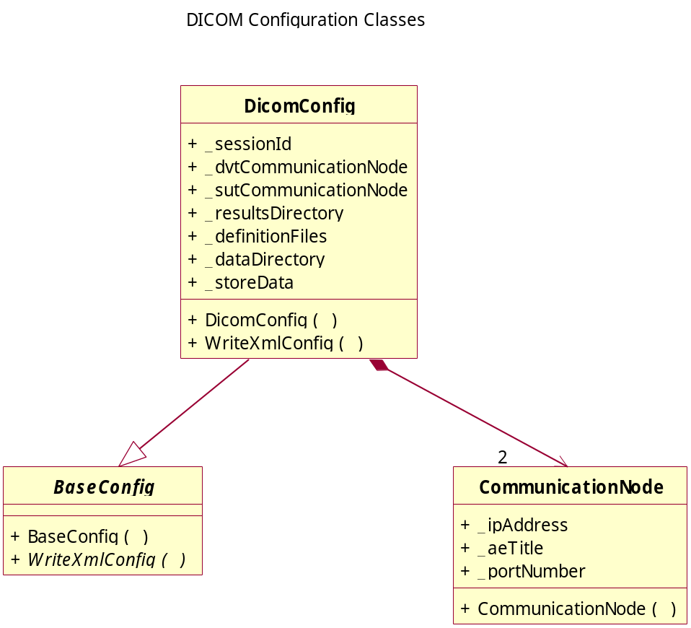

The DicomConfig class defines the configuration of one DICOM node either as SCP or SCU.

The CommunicationNode class is used to define the DVT and SUT communication parameters.

Hl7Config Class
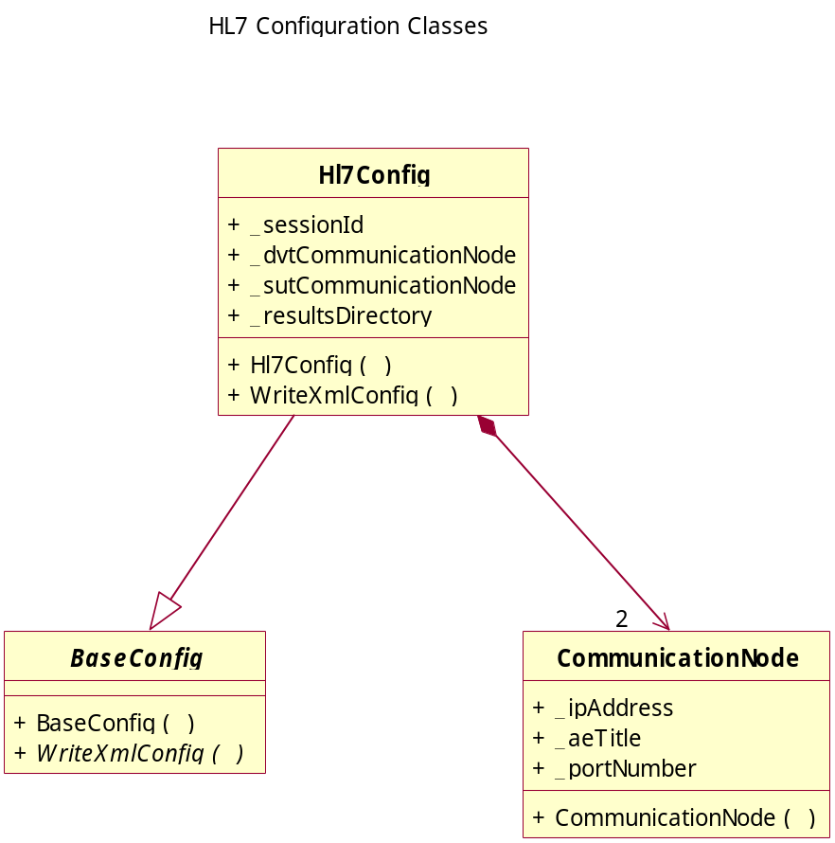

The Hl7Config class defines the configuration of one HL7 node either as Server or Client.

The CommunicationNode class is used to define the DVT and SUT communication parameters.

Example XML Configuration of the DVTK IHE DssOrderFiller Actor

<?xml version="1.0" encoding="us-ascii" standalone="yes"?>
<IheIntegrationProfile>
<IntegrationProfileName>Scheduled Workflow</IntegrationProfileName>
<IheActorConfiguration>
<ActorName>DssOrderFiller</ActorName>
<PeerIheActorDicomConfiguration>
<ActorName>AcquisitionModality</ActorName>
<SessionId>3</SessionId>
<DvtNode>
<AeTitle>DVT_AE</AeTitle>
<IpAddress>localhost</IpAddress>
<PortNumber>308</PortNumber>
</DvtNode>
<SutNode>
<AeTitle>SUT_AE</AeTitle>
<IpAddress>localhost</IpAddress>
<PortNumber>104</PortNumber>
</SutNode>
<DataDirectory>C:\Program Files\DVT20\data\worklist</DataDirectory>
<StoreData>False</StoreData>
<DefinitionFiles>
<DefinitionFile>C:\Program Files\DVT20\definitions\ModalityWorklist-FIND.def</DefinitionFile>
</DefinitionFiles>
<ResultsRootDirectory>C:\Program Files\DVT20\results</ResultsRootDirectory>
</PeerIheActorDicomConfiguration>
<PeerIheActorDicomConfiguration>
<ActorName>PerformedProcedureStepManager</ActorName>
<SessionId>3</SessionId>
<DvtNode>
<AeTitle>DVT_AE</AeTitle>
<IpAddress>localhost</IpAddress>
<PortNumber>408</PortNumber>
</DvtNode>
<SutNode>
<AeTitle>DVT_PM</AeTitle>
<IpAddress>localhost</IpAddress>
<PortNumber>104</PortNumber>
</SutNode>
<DataDirectory>.</DataDirectory>
<StoreData>False</StoreData>
<DefinitionFiles>
<DefinitionFile>C:\Program Files\DVT20\definitions\ModalityPerformedProcedureStep.def</DefinitionFile>
</DefinitionFiles>
<ResultsRootDirectory>C:\Program Files\DVT20\results</ResultsRootDirectory>
</PeerIheActorDicomConfiguration>
</IheActorConfiguration>
</IheIntegrationProfile>

This shows the DssOrderFiller actor configured for two peer devices being a DICOM connection for the AcquisitionModality to perform a worklist query and a DICOM connection to accept the MPPS messages from the PPSManager.

That is, the DssOrderFiller actor will act as a DICOM SCP pending on TCP/IP port 308 for Modality Worklist queries from the acquisition modality and as a DICOM SCP pending on TCP/IP port 408 for MPPS messages from the PPSManager.

Actor Classes

ActorCollection Class
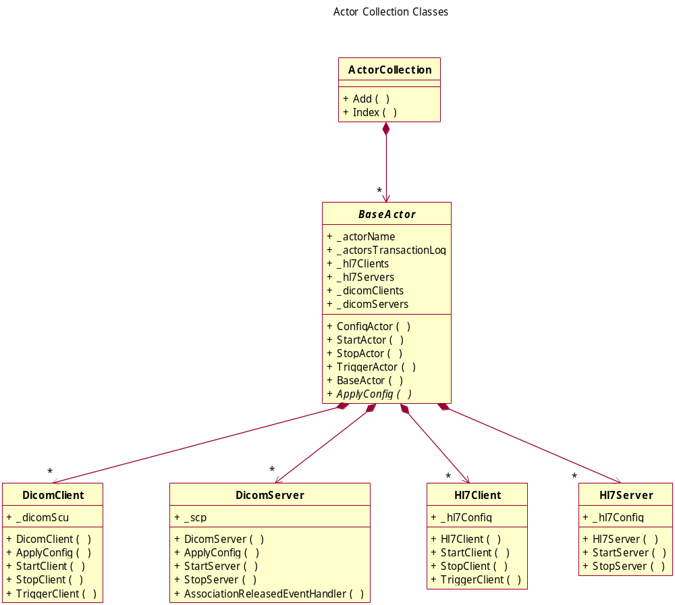

The ActorCollection class defines all the actors that take part in the integration profile with the SUT.

Each actor is defined by a specialization of the BaseActor class. This class can contain 0..n DicomClients, 0..n DicomServers, 0..n Hl7Clients and 0..n Hl7Servers. The actual content is defined by the actor being realized.

All actors implement the ConfigActor(), StartActor() and StopActor() methods with calls being delegated to the underlying DICOM and HL7 Clients and Servers.

The TriggerActor() method is only implemented by the DICOM and HL7 Clients as a means of triggering the client to do something.

Actor Class
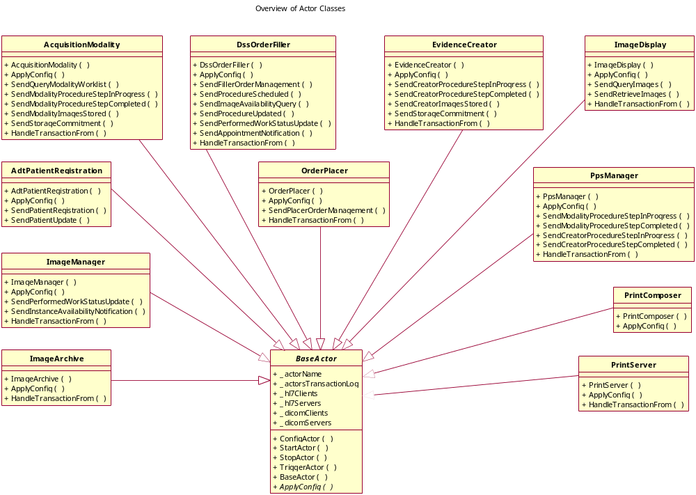

The BaseActor class defines an abstract ApplyConfig() method which is implemented in the specialized actor classes. The specialized actor class knows which DICOM / HL7 Clients / Servers are needed – if these are defined in the ActorConfig then they will be instantiated in the specialized actor class.

Example code snippet from the DssOrderFiller actor class:

/// <summary>
/// Apply the Actor Configuration.
/// </summary>
/// <param name="actorConfig">Actor Configuration.</param>
protected override void ApplyConfig(ActorConfig actorConfig)
{
// for receiving Patient Registration [RAD-1]
// for receiving Patient Update [RAD-12]
AddHl7Server(ActorNameEnum.AdtPatientRegistration, actorConfig);

// for receiving Placer Order Management [RAD-2]
AddHl7Server(ActorNameEnum.OrderPlacer, actorConfig);

// for receiving Query Modality Worklist [RAD-5]
AddDicomServer(new DicomWorklistServer(this,
ActorNameEnum.AcquisitionModality),
actorConfig);

// for receiving Modality Procedure Step In Progress [RAD-6]
// for receiving Modality Procedure Step Completed [RAD-7]
// for receiving Creator Procedure Step In Progress [RAD-20]
// for receiving Creator Procedure Step Completed [RAD-21]
AddDicomServer(new DicomMppsServer(this,
ActorNameEnum.PerformedProcedureStepManager),
actorConfig);

// for receiving Instance Availability Notification [RAD-49]
AddDicomServer(ActorNameEnum.ImageManager, actorConfig);

// for sending Filler Order Management [RAD-3]
// for sending Appointment Notification [RAD-48]
AddHl7Client(ActorNameEnum.OrderPlacer, actorConfig);

// for sending Procedure Scheduled [RAD-4]
// for sending Procedure Updated [RAD-13]
AddHl7Client(ActorNameEnum.ImageManager, actorConfig);

// for sending Image Availability Query [RAD-11]
// for sending Performed Work Status Update [RAD-42]
AddDicomClient(ActorNameEnum.ImageManager, actorConfig);
}

The AddDicomServer, AddDicomClient, AddHl7Server and AddHl7Client methods will only add the appropriate client or server if the configuration of the peer actor is found in the actorConfig.

So the Hl7Server for the AdtPatientRegistration peer actor used to handle transactions RAD-1 and RAD-12 will only be added if the configuration for this AdtPatientRegistration actor is found in the peer configuration of the DssOrderFiller actor.

The HandleTransactionFrom() method handles either DICOM or HL7 transactions from the peer devices. Internal actions based on the actor function and transaction type will take place.

Most of the specialized actors have a number of Send…() methods which are used to send the specific kind of transaction associated with the actor – example, the AcquisitionModality actor has a SendQueryModalityWorklist() method which is used to trigger the AcquisitionModality to send a CFIND Modality Worklist Query to the DssOrderFiller actor.
The names used for the Send…() methods correspond to the transaction names used in the IHE Technical Framework.

DicomServer Class
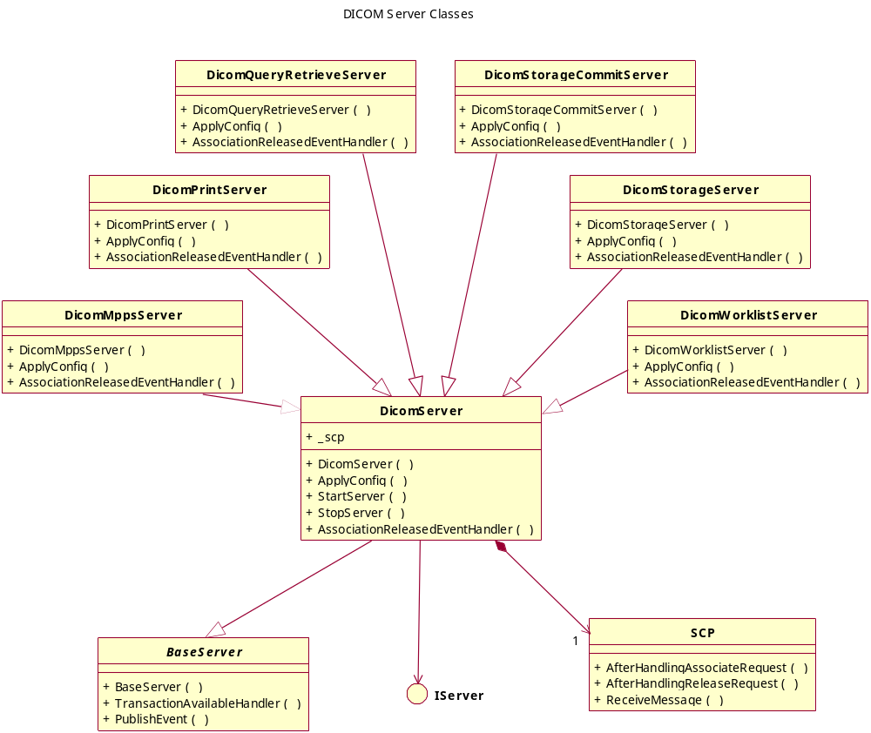

The DicomServer class encapsulates the DvtkHighLevelInterface SCP class which handles standard SCP functionality – that is, waiting for an associate request, accepting the appropriate SOP Classes, waiting for DICOM messages and then handling the association release.

This SCP class is therefore pending on a TCP/IP socket for the peer association once started. After handling an association the SCP waits for a new peer association.

An event is fired after the association has been handled. This event is used to collect all the messages exchanged during the association and add these to a DICOM transaction. This DICOM transaction is then added to the ActorsTransactionLog class for later processing.

The DicomServer Class is specialized is section - Detailed Design of the Specialized DICOM Server Classes.

DicomClient Class
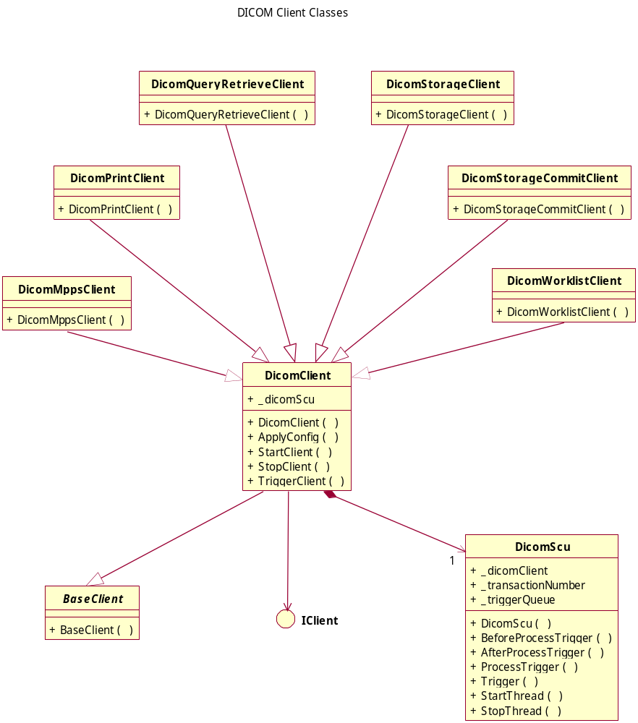

The DicomClient class encapsulates the DicomScu class which is a specialization of the DvtkHighLevelInterface SCU class. This SCU class handles standard SCU functionality – that is, sending an associate request, handling the association acceptance and sending DICOM messages and finally releasing the association.
The implementation of the SCU used by the DicomScu is that the SCU class is pending on a message queue for a trigger to process. The trigger is the DICOM message set that should be sent over the association.

The TriggerClient() method is used to send a trigger to the SCU (queue a message to be processed).

The specialized DICOM clients vary only by the SOP Classes proposed during the association and the triggers accepted by them.

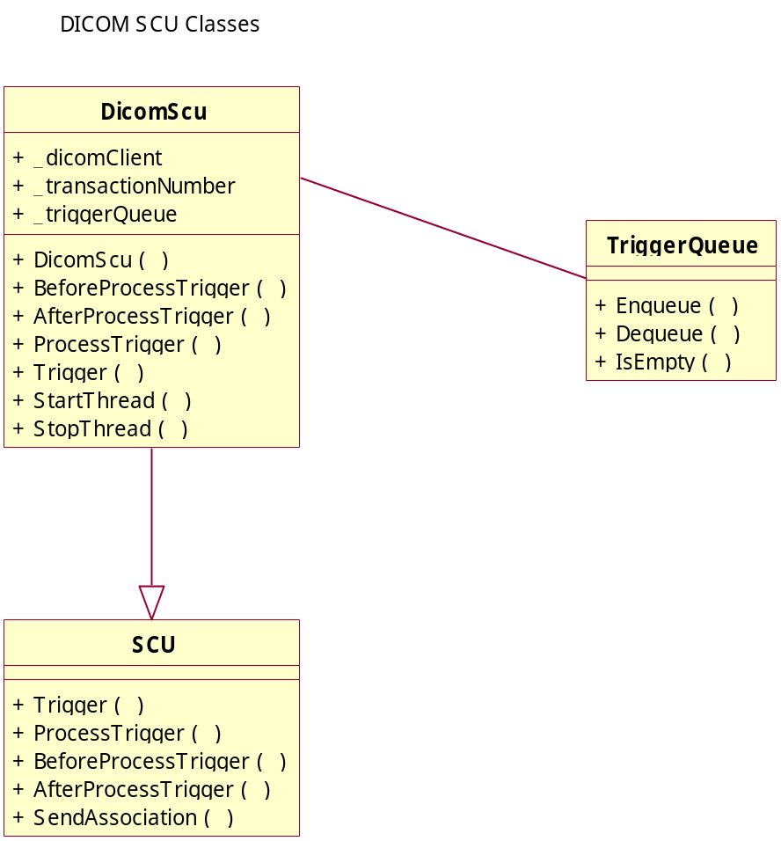

The BeforeProcessTrigger() and AfterProcessTrigger() allow the specialized DicomScu class to do the pre and post trigger operations needed by the DICOM Clients.

The post trigger operation is used to collect all the messages exchanged during the association and add these to a DICOM transaction. This DICOM transaction is then added to the ActorsTransactionLog class for later processing.

Hl7Server Class
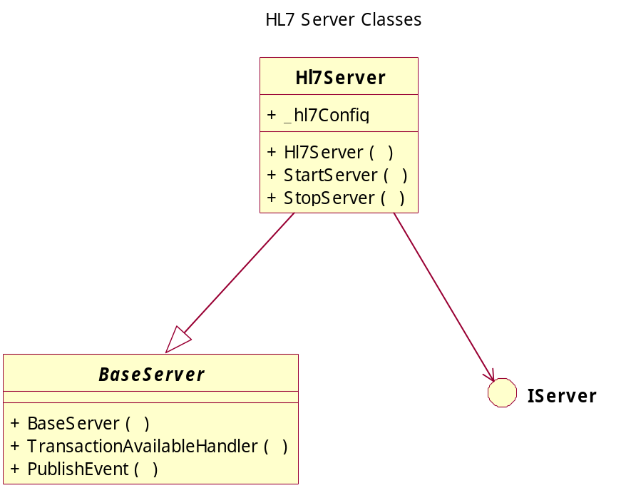

To be further defined.

Hl7Client Class
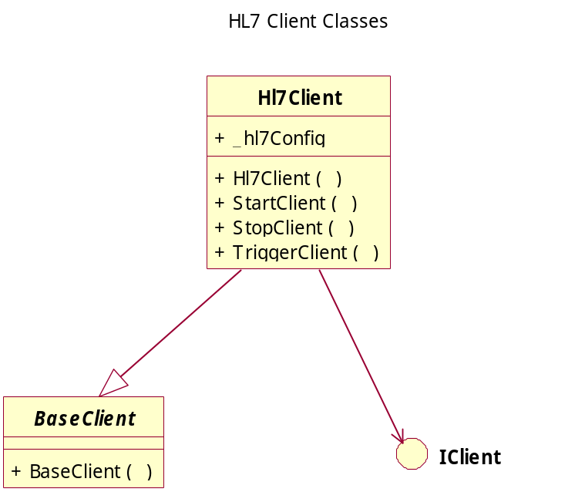

To be further defined.

Transaction Classes

ActorsTransactionLog Class
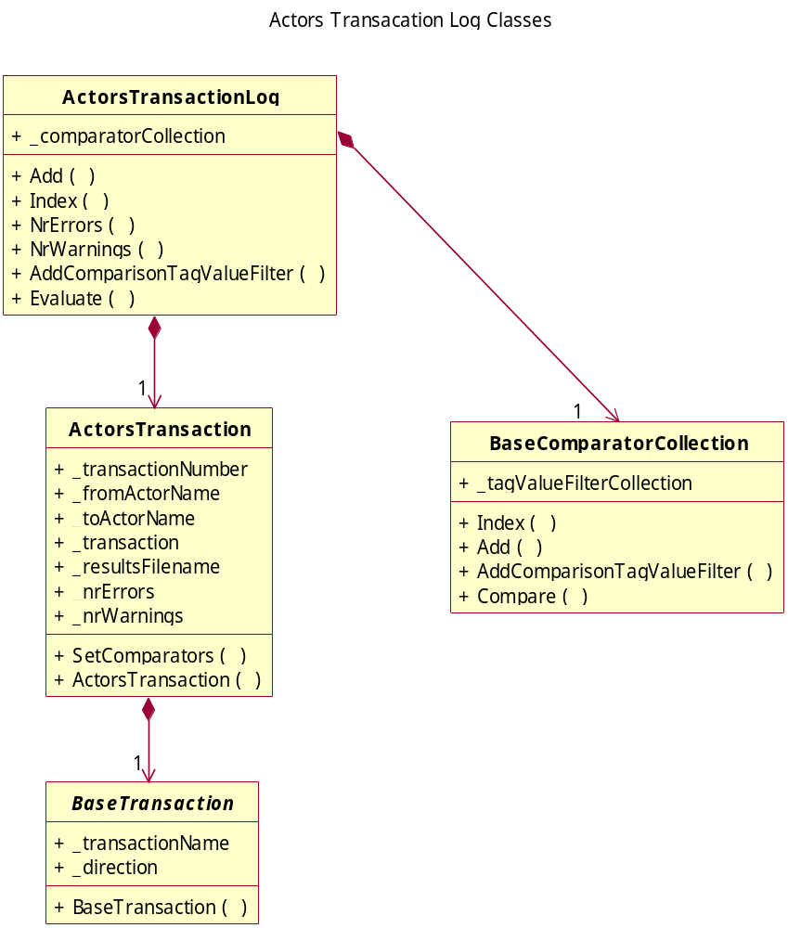

The ActorsTransactionLog class is a container for all DICOM and HL7 transactions taking place between actors during the test. This log is evaluated at the end of the test and is used to compare attribute values between various messages in the transactions. The comparison is done using comparators – see section - Detailed Design of the Comparator Classes.

The ActorsTransaction class contains all the transactions handled by a single actor. These can be a combination of DICOM and HL7 transactions.

DicomTransaction Class
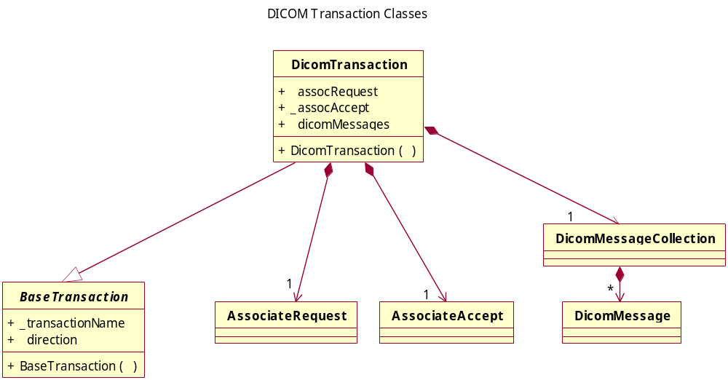

A DICOM transaction consists of the association request and accept messages together with all the DICOM messages exchanged during the association. The AssociateRequest, AssociateAccept and DicomMessage(Collection) classes are defined in the DvtkHighLevelInterface assembly.

Hl7Transaction Class
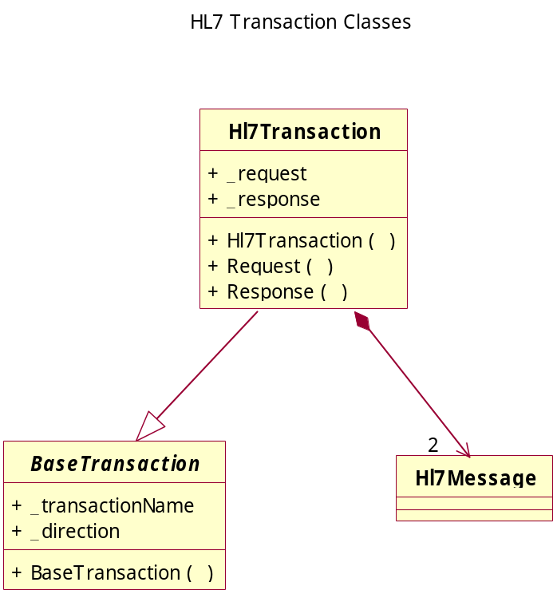

An HL7 transaction consists of the HL7 request and response message pair.

Trigger Classes

DicomTrigger Class
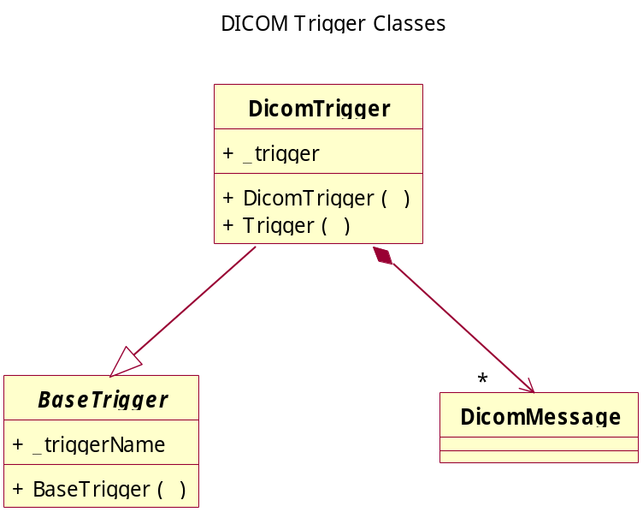

A DICOM trigger consists of a DicomMessage(Set) that needs to be sent over an association by an SCU. The DicomMessage class is defined in the DvtkHighLevelInterface assembly.

Hl7Trigger Class
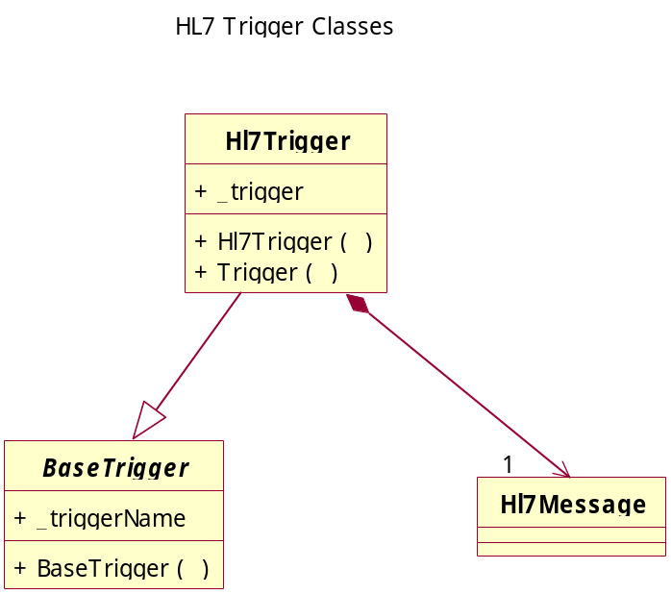

An HL7 trigger consists of the HL7 Request that needs to be sent by the HL7 Client to a peer server.

Sequence Diagrams

DICOM Server Lifecycle
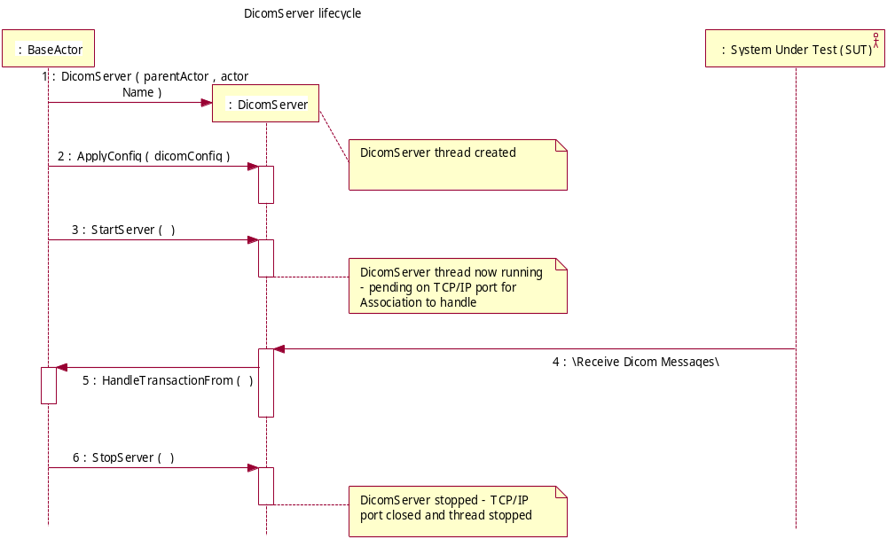

The above sequence diagram shows the lifecycle of a typical DICOM Server. Once the server is started, it will handle incoming transactions (DICOM Messages) until it is stopped.

DICOM Client Lifecycle
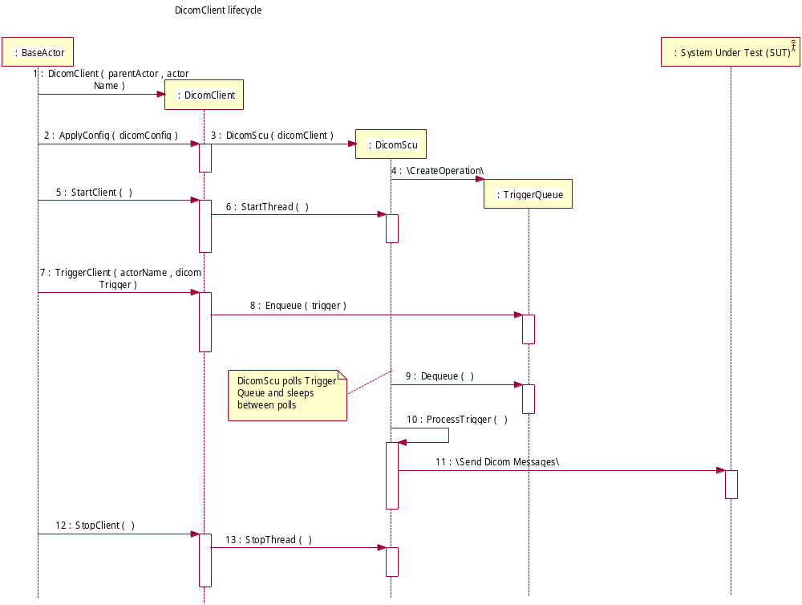

The above sequence diagram shows the lifecycle of a typical DICOM Client. Once the client is started, it polls a trigger queue for triggers to process until it is stopped.

HL7 Server Lifecycle
To be defined.

HL7Client Lifecycle
To be defined.

Detailed Design of the Specialized DICOM Server Classes

Introduction
The specialized DICOM server classes take the generalized DvtkHighLevelInterface SCP class and specialize it with the appropriate message handlers. The message handlers are defined in the DvtkDicomMessageHandler assemblies. The specialized Scp classes are defined in the DvtkDicomClientServer assemblies.

Overview of Major Participating Classes

DICOM Server Classes

DicomMppsServer Class
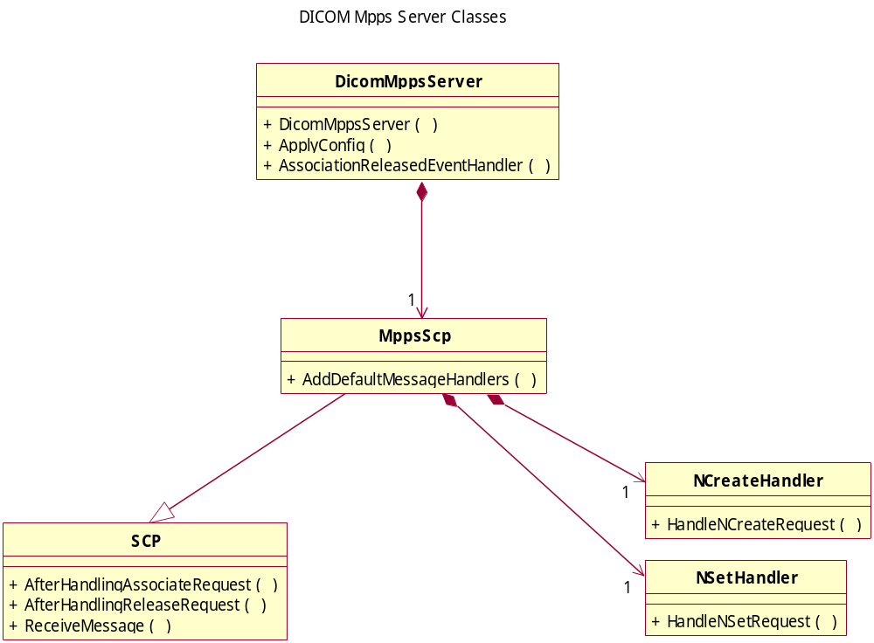

The DicomMppsServer supports the NCreate and NSet of MPPS messages via the message handler classes added.

DicomPrintServer Class
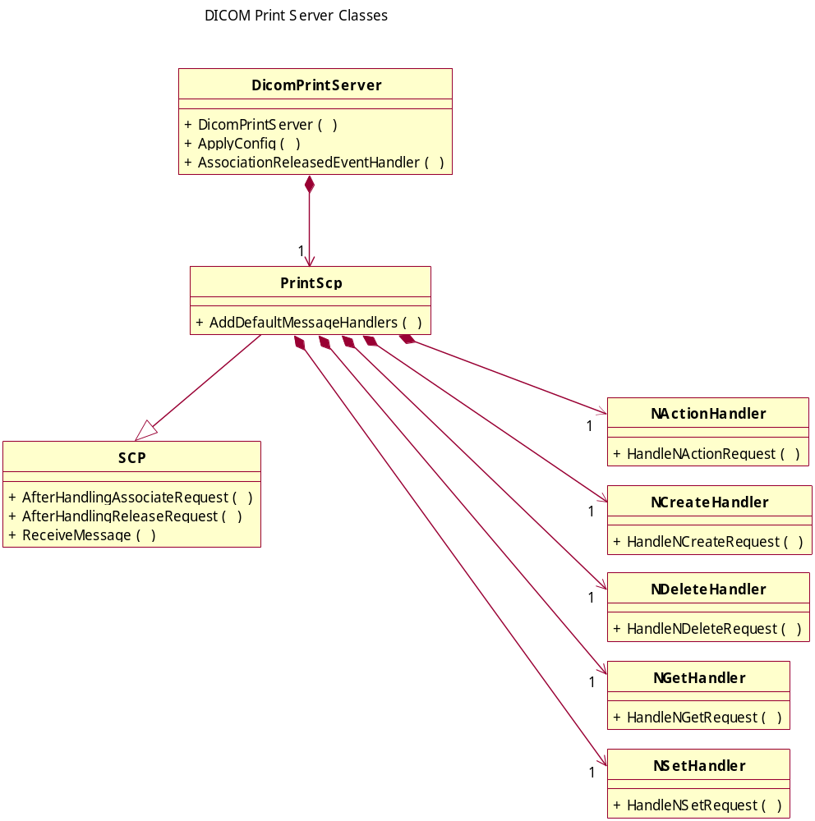

The DicomPrintServer supports the NAction, NCreate, NDelete, NGet and NSet of Print messages via the message handler classes added.

DicomQueryRetrieveServer Class
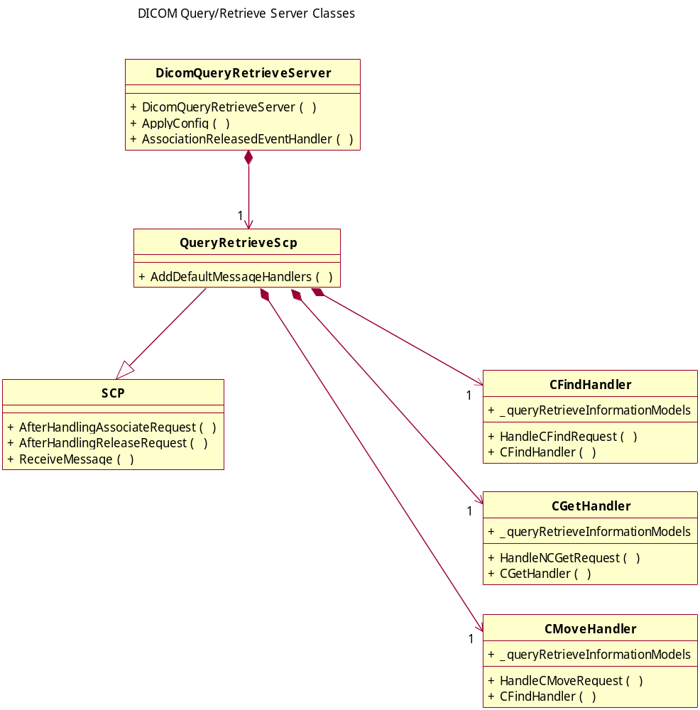

The DicomQueryRetrieveServer supports the CFind, CGet and CMove of Query/Retrieve messages via the message handler classes added. The CFind, CMove and CGet are done against the Query/Retrieve Information Models – see section - Detailed Design of the Information Entity Classes.

DicomStorageServer Class
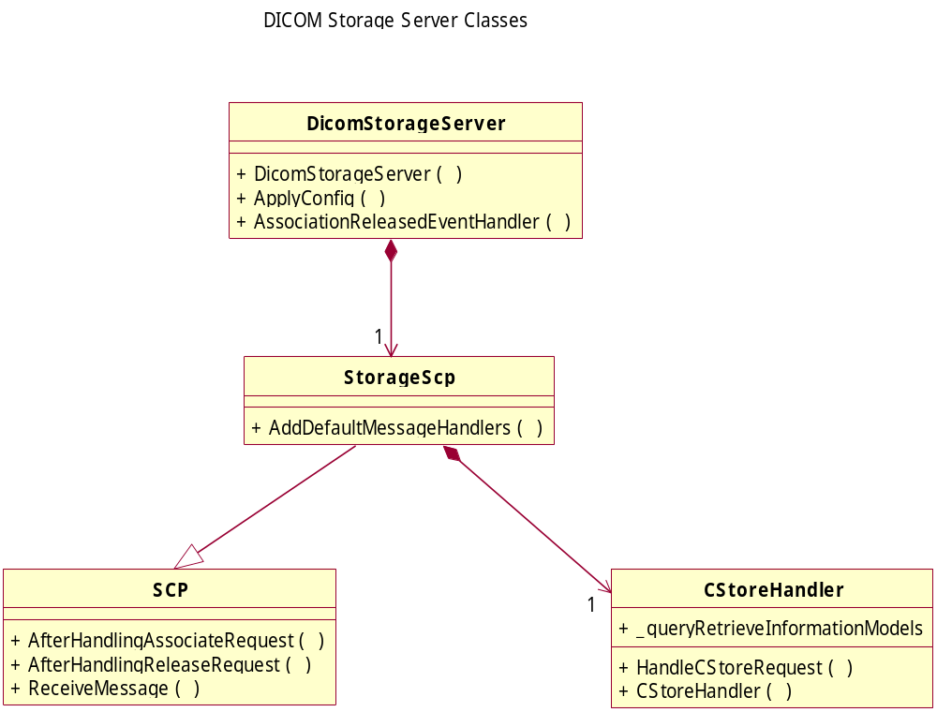

The DicomStorageServer supports the CStore of Instance messages via the message handler class added. The CStore updates the Query/ Retrieve Information Models – see section - Detailed Design of the Information Entity Classes.

DicomStorageCommitServer Class
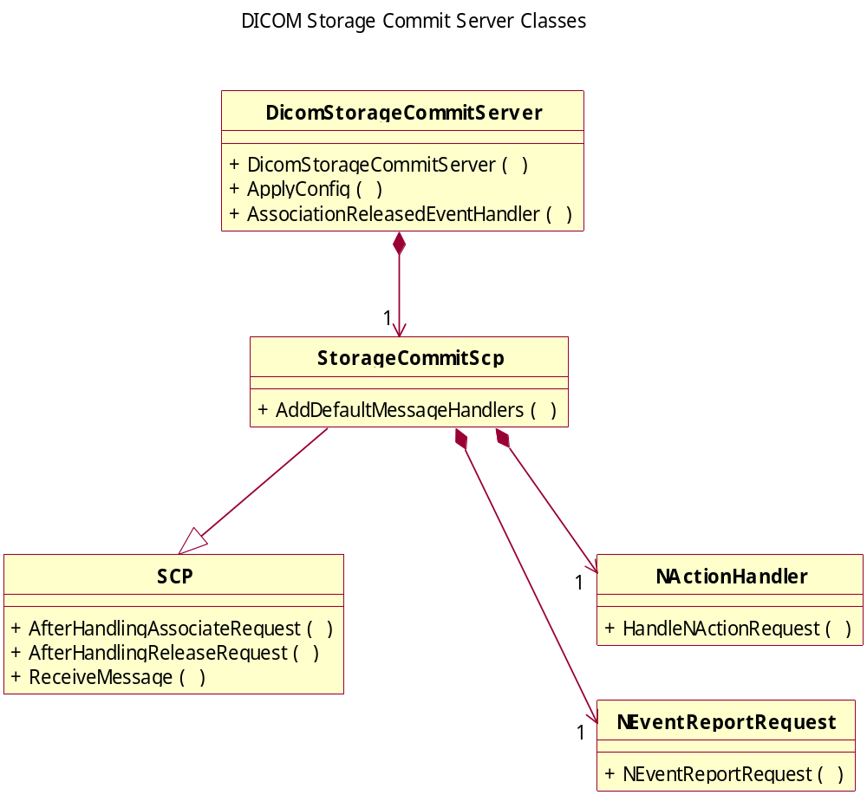

The DicomStorageCommitServer supports the NAction of Storage Commit messages via the message handler class added.

DicomWorklistServer Class
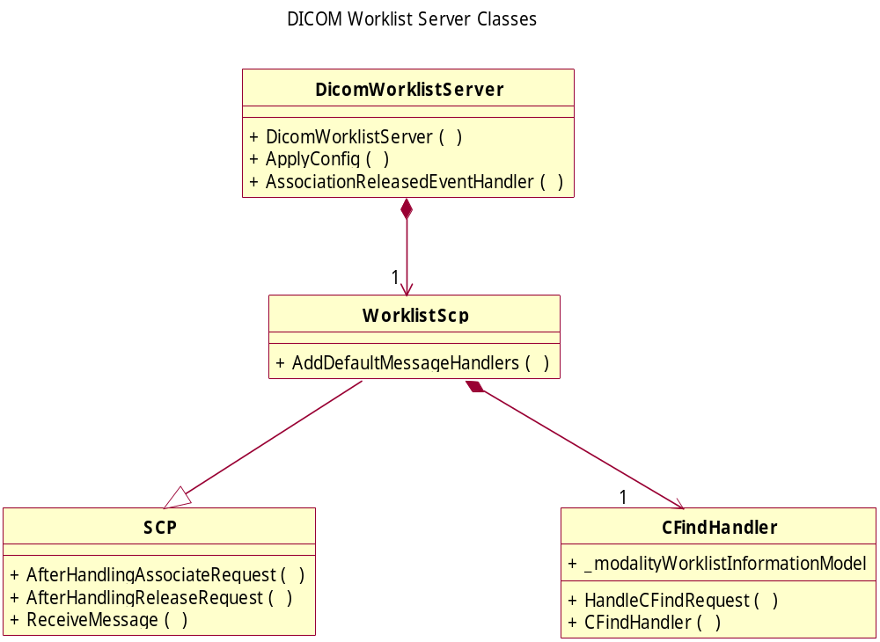

The DicomWorklistServer supports the CFind of Modality Worklist messages via the message handler classes added. The CFind is done against the Modality Worklist Information Model – see section - Detailed Design of the Information Entity Classes.

Detailed Design of the Information Entity Classes

Introduction
The DvtkInformationEntity assembly provides Information Models for the Query/Retrieve and Modality Worklist services. These Information Models can be populated by reading either Storage or Worklist DCM files into the Information Models – the data in the DCM files is normalized into the appropriate information entity.

Overview of Major Participating Classes

Query/Retrieve Classes

Query/Retrieve Information Entity Classes
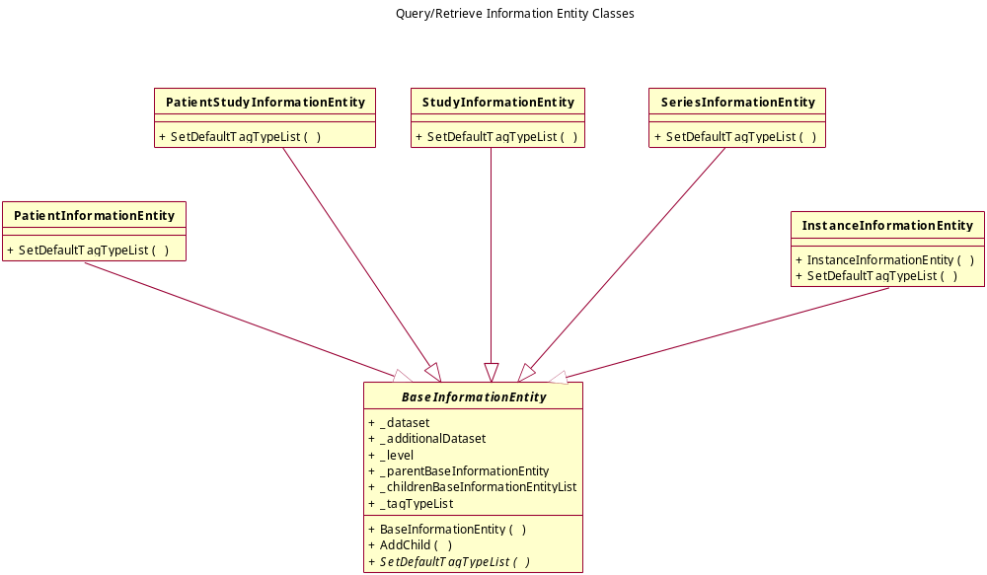

The InformationEntity classes contain TagTypeLists which identify the DICOM Tags that are part of the information entity and whether the tags are the Unique Keys or Optional Keys in the Information Model.

A specialized InformationEntity, for example, PatientInformationEntity is populated during the reading of the DCM files and inserted into the Information Model the first time it occurs. The addition of the next level StudyInformationEntity will first find the corresponding parent PatientInformationEntity and then be added to that parent.

Patient Root Query/Retrieve Information Model Classes
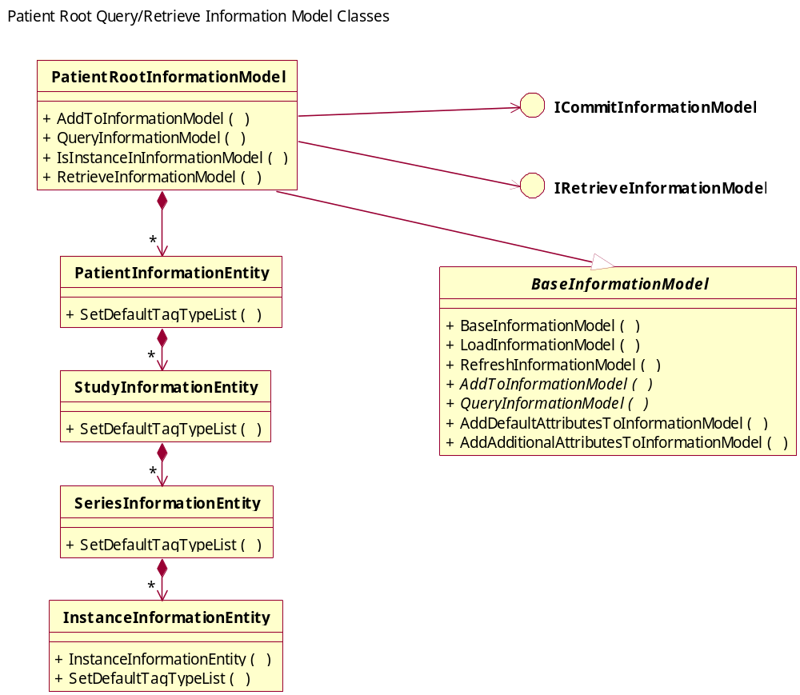

The PatientRootInformationModel provides the Query/Retrieve capability when the Patient Root Query/Retrieve Information Model SOP Classes are being used.

The Information Model can be queried by the C-FIND-RQ Identifier (Dataset) using the QueryInformationModel() method with the corresponding responses being returned as a collection of C-FIND-RSP Datasets.

The Information Model can be retrieved by the C-GET-RQ/C-MOVE-RQ identifier (Dataset) using the RetrieveInformationModel() method with the corresponding responses being a list of storage DCM files. These storage DCM files can then be given to a DICOM Storage Client for transmission to the retrieve AE Title.

The Information Model can also be checked to see if it contains an instance with a corresponding SOP Class/Instance UID using the IsInstanceInInformationModel() method. This allows the Information Model to assist in the support of the Storage Commitment SOP Class.

Study Root Query/Retrieve Information Model Classes
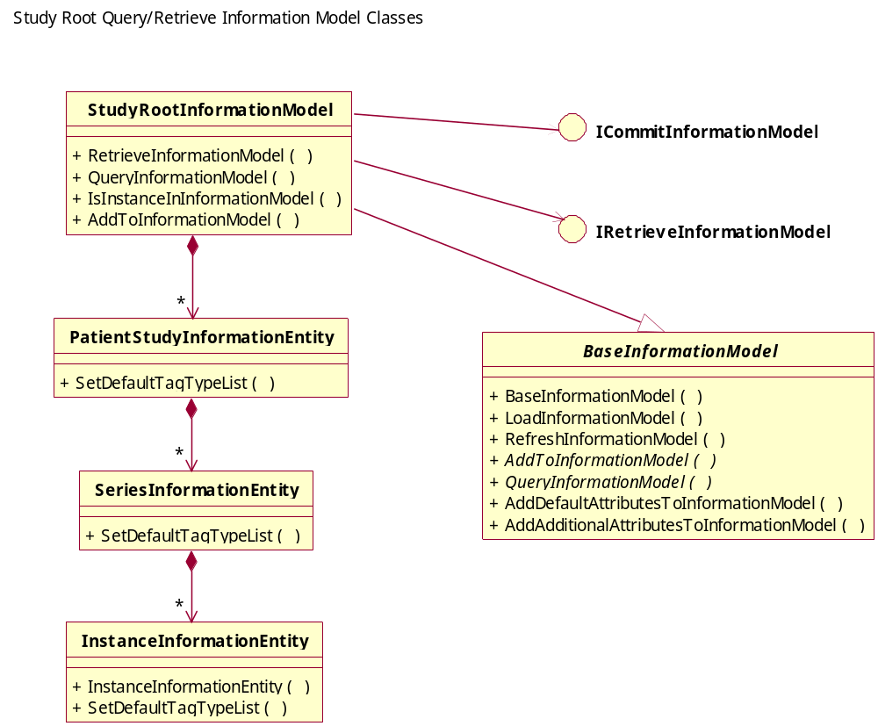

The StudyRootInformationModel provides the Query/Retrieve capability when the Study Root Query/Retrieve Information Model SOP Classes are being used.

Patient/Study Only Information Model Classes
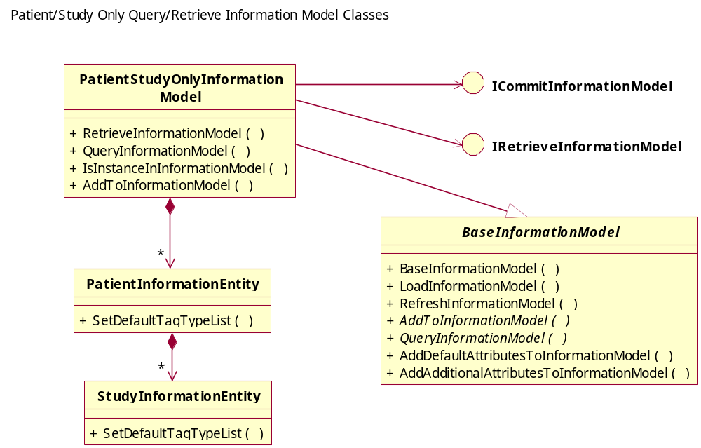

The PatientStudyOnlyInformationModel provides the Query/Retrieve capability when the Patient Study Only Query/Retrieve Information Model SOP Classes are being used.

Modality Worklist Classes

Modality Worklist Information Entity Classes
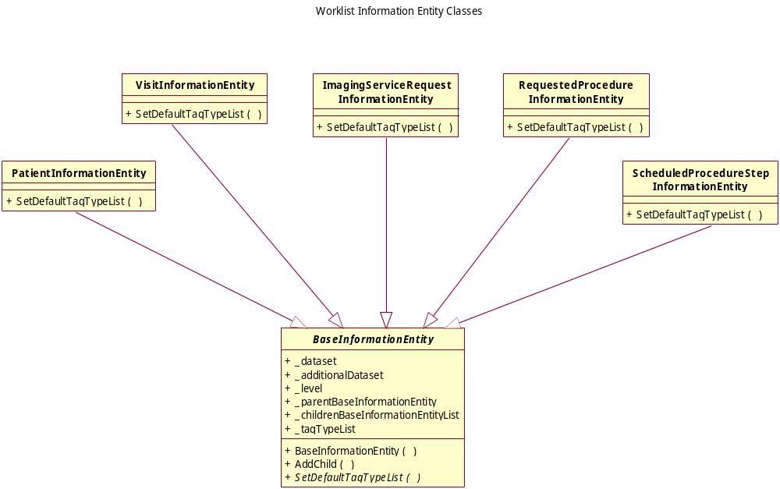
Example code snippet from the ScheduledProcedureStep.SetDefaultTagTypeList() method:

/// <summary>
/// Set the Default Tag Type List for this Entity.
/// </summary>
protected override void SetDefaultTagTypeList()
{
TagTypeList.Add(new TagType(Tag.SCHEDULED_STATION_AE_TITLE,
VR.AE, TagTypeEnum.TagRequired));
TagTypeList.Add(new TagType(Tag.SCHEDULED_PROCEDURE_STEP_START_DATE,
VR.DA, TagTypeEnum.TagRequired));
TagTypeList.Add(new TagType(Tag.SCHEDULED_PROCEDURE_STEP_START_TIME,
VR.TM, TagTypeEnum.TagRequired));
TagTypeList.Add(new TagType(Tag.MODALITY,
VR.CS, TagTypeEnum.TagRequired));
TagTypeList.Add(new TagType(Tag.SCHEDULED_PERFORMING_PHYSICIANS_NAME,
VR.PN, TagTypeEnum.TagRequired));
TagTypeList.Add(new TagType(Tag.SCHEDULED_PROCEDURE_STEP_DESCRIPTION,
VR.LO, TagTypeEnum.TagOptional));
TagTypeList.Add(new TagType(Tag.SCHEDULED_STATION_NAME,
VR.SH, TagTypeEnum.TagOptional));
TagTypeList.Add(new TagType(Tag.SCHEDULED_PROCEDURE_STEP_LOCATION,
VR.SH, TagTypeEnum.TagOptional));
TagTypeList.Add(new TagType(Tag.SCHEDULED_ACTION_ITEM_CODE_SEQUENCE,
VR.SQ, TagTypeEnum.TagOptional));
TagTypeList.Add(new TagType(Tag.PRE_MEDICATION,
VR.LO, TagTypeEnum.TagOptional));
TagTypeList.Add(new TagType(Tag.SCHEDULED_PROCEDURE_STEP_ID,
VR.SH, TagTypeEnum.TagOptional));
TagTypeList.Add(new TagType(Tag.REQUESTED_CONTRAST_AGENT,
VR.LO, TagTypeEnum.TagOptional));
TagTypeList.Add(new TagType(Tag.SCHEDULED_PROCEDURE_STEP_STATUS,
VR.CS, TagTypeEnum.TagOptional));
// plus all other attributes from the Scheduled Procedure Step Module
}

These TagTypeLists should be loadable to allow various test scenarios to be supported.

Modality Worklist Information Model Classes
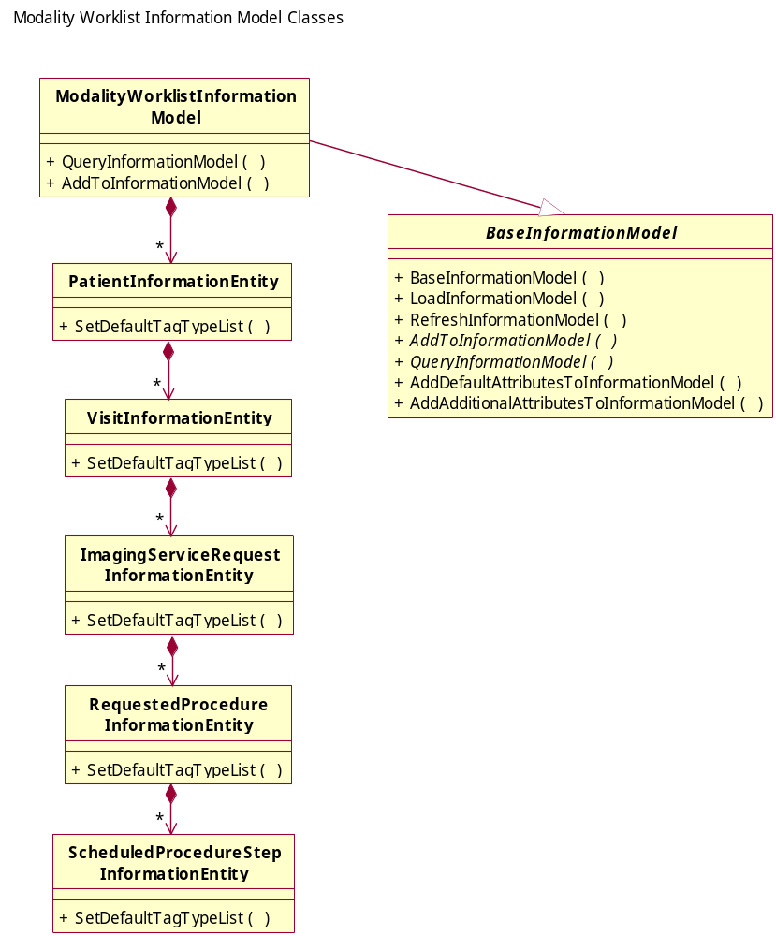

The ModalityWorklistInformationModel provides the Query capability when the CFIND Modality Worklist SOP Class is being used.

Detailed Design of the Comparator Classes

Introduction
The DvtkComparator assembly provides the attribute value comparison capability between attributes in various messages.

The comparator is initialized with a template containing the attribute tags that are candidates for comparison for a given message – together with a class that can hold the common data format of the value of the attribute corresponding to each tag.

Then the message to be compared is extracted out of the IHE Transaction and the comparator filled with the values of the tags defined in the comparator that are found in the message.

The same is done for a second message and then the two comparators are compared against each other. Any attributes found in comparator one are searched for in comparator two. If both comparators contain the tags then their values are compared.

It is possible to apply a filter to the comparators indicating which tags must be present in a message before any of the other attributes in the comparator will be compared. This filter may include values for tags so that the comparison is further filtered on messages which contain the same tags with the same values.

Overview of Major Participating Classes

BaseComparatorCollection Class
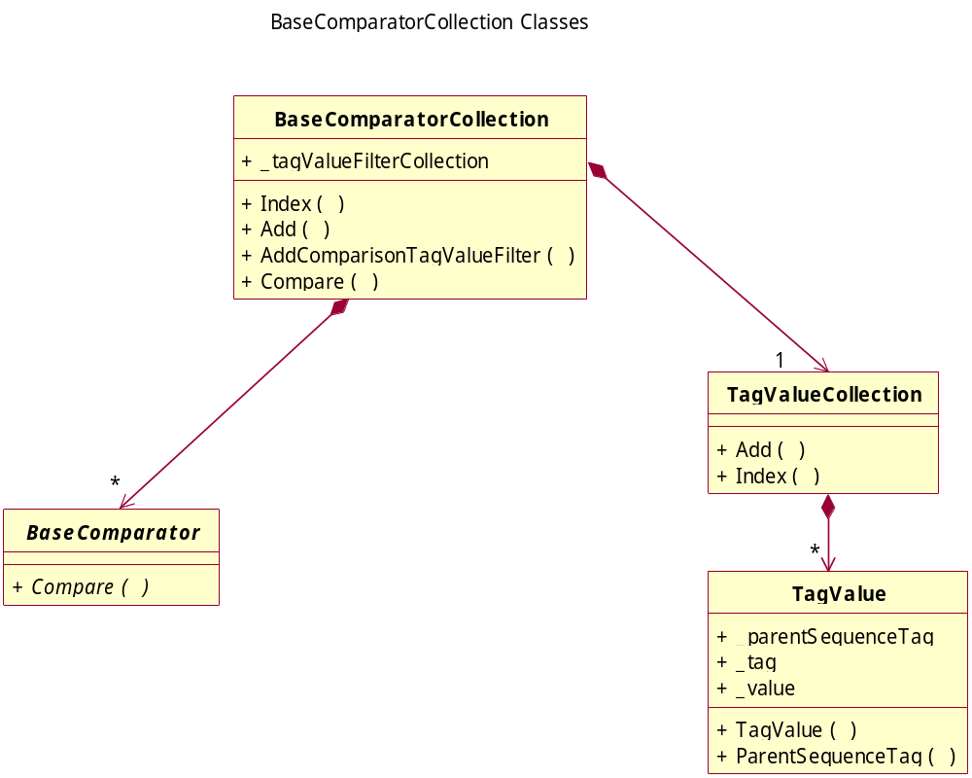

The BaseComparatorCollection class contains all the comparators that have been set up from all the messages in the ActorsTransactionLog. The _tagValueFilterCollection is the list of tag/value pairs that are defined to filter out the comparators that should be compared with each other.

Code snippet setting these filters through the IntegrationProfile class:

//
// Add filters (as Tag Values) to the Comparator
//
// Universal Match on these DICOM Tags
integrationProfile.AddComparisonTagValueFilter(new TagValue(Tag.PATIENT_ID));
integrationProfile.AddComparisonTagValueFilter(new TagValue(Tag.ACCESSION_NUMBER));

// Single Value Match on these DICOM Tags
integrationProfile.AddComparisonTagValueFilter(
new TagValue(Tag.PATIENTS_BIRTH_DATE,
"19000101"));
integrationProfile.AddComparisonTagValueFilter(
new TagValue(Tag.REQUESTED_PROCEDURE_ID,
"RPQ2"));

This has the effect of setting filters which will mean that only messages which contain the same values for the Patient_Id and Accession_Number will be compared as long as the messages contain the Patient Birth Date attribute with value “19000101” and Requested Procedure Id attribute with value “RPQ2”.

When no filters are applied, all messages in the ActorsTransactionLog will be compared with each other using the comparators.

DicomComparator Class
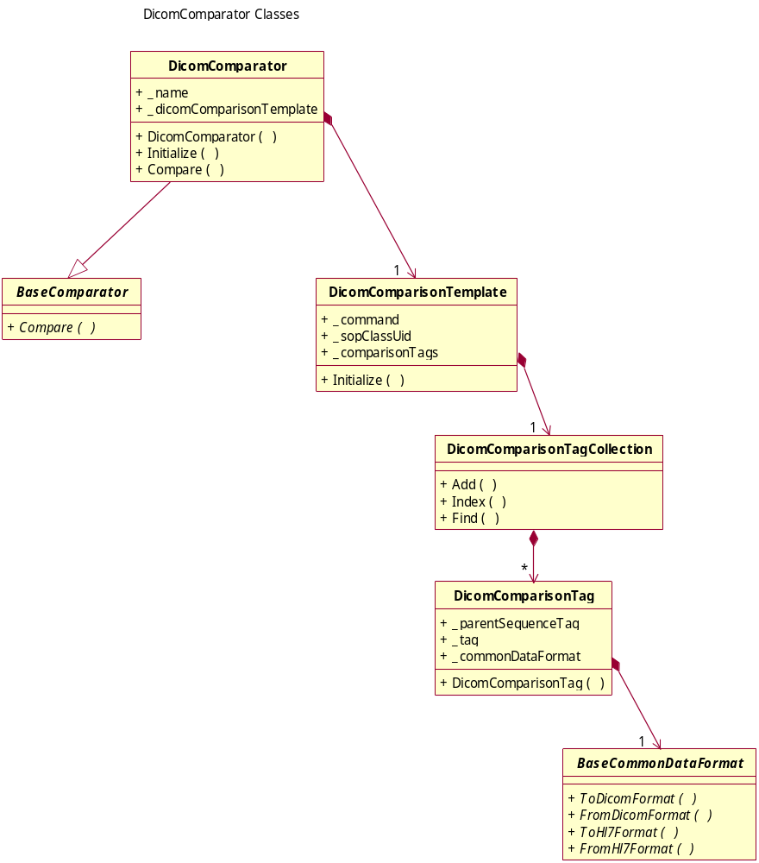

Example code snippet from the DicomComparisonTemplate.Initialize() method for the CFIND Modality Worklist Query response:

// Add the comparison tags - these tags will be used to extract the values out of the
// Dicom Dataset for comparison with other Datasets containing the same tags
_comparisonTags.Add(new DicomComparisonTag(Tag.ACCESSION_NUMBER,
new CommonIdFormat()));
_comparisonTags.Add(new DicomComparisonTag(Tag.MODALITY,
new CommonStringFormat()));
_comparisonTags.Add(new DicomComparisonTag(Tag.REFERENCED_STUDY_SEQUENCE,
new CommonUidFormat()));
_comparisonTags.Add(new DicomComparisonTag(Tag.PATIENTS_NAME,
new CommonNameFormat()));
_comparisonTags.Add(new DicomComparisonTag(Tag.PATIENT_ID,
new CommonIdFormat()));
_comparisonTags.Add(new DicomComparisonTag(Tag.PATIENTS_BIRTH_DATE,
new CommonDateFormat()));
_comparisonTags.Add(new DicomComparisonTag(Tag.PATIENTS_SEX,
new CommonStringFormat()));
_comparisonTags.Add(new DicomComparisonTag(Tag.STUDY_INSTANCE_UID,
new CommonUidFormat()));
_comparisonTags.Add(new DicomComparisonTag(Tag.REQUESTED_PROCEDURE_ID,
new CommonIdFormat()));
_comparisonTags.Add(new DicomComparisonTag(Tag.SCHEDULED_PROCEDURE_STEP_SEQUENCE,
Tag.SCHEDULED_PROCEDURE_STEP_ID,
new CommonIdFormat()));
_comparisonTags.Add(new DicomComparisonTag(Tag.REQUESTED_PROCEDURE_DESCRIPTION,
new CommonStringFormat()));
_comparisonTags.Add(new DicomComparisonTag(Tag.SCHEDULED_PROCEDURE_STEP_SEQUENCE,
Tag.SCHEDULED_PROCEDURE_STEP_DESCRIPTION,
new CommonStringFormat()));

Similar lists are used for the Image Storage messages and MPPS messages. This allows these message types to be compared with each other when the corresponding tags are found in any two messages be compared.

Detailed Design of the Common Data Format Classes

Introduction
The DvtkCommonDataFormat assembly provides classes that translate DICOM and HL7 data formats into a common format so that values appearing in HL7 messages can be directly compared to those in DICOM messages. The comparison being done by converting both HL7 and DICOM data formats into the common one.

The assembly will be extended with other protocol types as needed to support new Integration Profiles.

Overview of Major Participating Classes

Common Data Format Classes
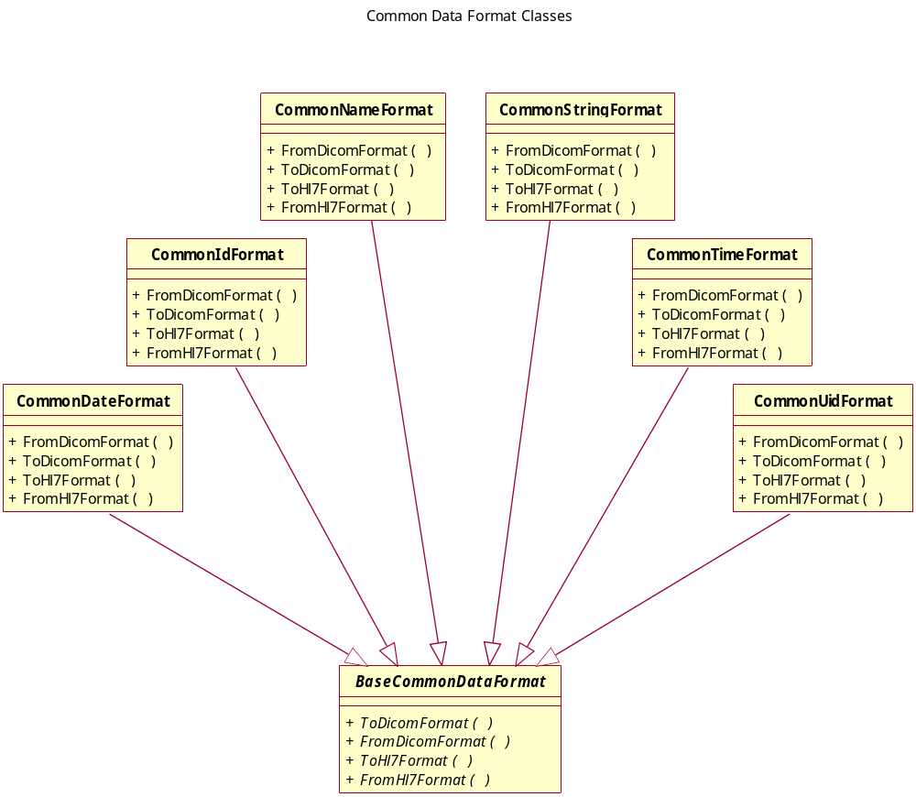

The classes identified so far provide To/From DICOM/HL7 methods to get data in the appropriate format. The Common format can be compared between two values using the specialized Equals() method.

DVTK Assembly Dependencies

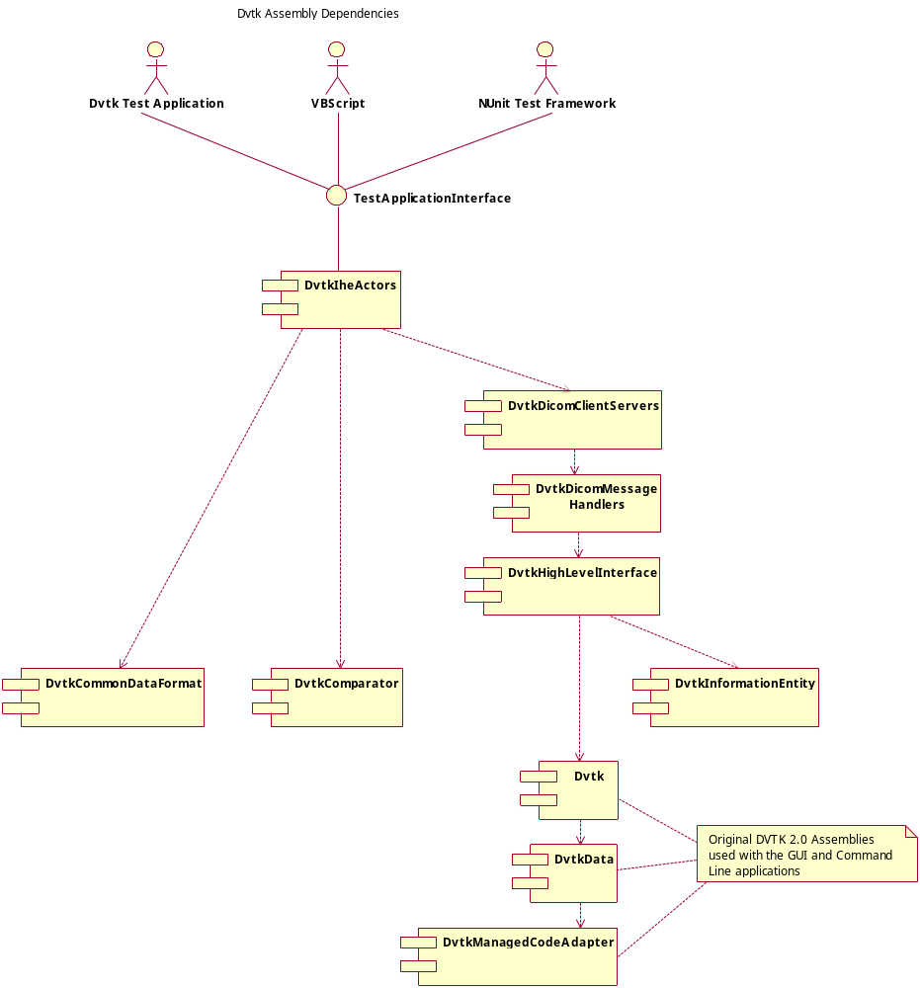

There will be additional dependencies for the DVTK IHE Actors assembly once the HL7 message generation, transport and validation libraries have been defined.

A Worklist DCM file is special to DVTK and contains a C-FIND-RSP Modality Worklist Query response dataset. These include the File Meta Information which identifies the find content as being a worklist response.

